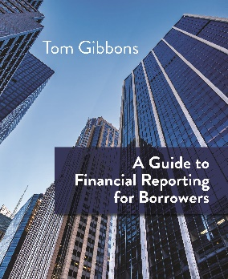
Keynote Speaker: Tom Gibbons

616-540-7540 | GuidetoReporting@outlook.com | GuidetoReporting.com

Keynote Proposal

Improving commercial financial reporting beyond legal requirements making it easier and faster to obtain loan approvals and better management information.

Keynote Description

Why is obtaining commercial loan approvals and relevant management information so difficult?

- Don’t scramble for vital information just prior to your loan being approved with one-off conversations.
- Instead, implement a standardized system of reporting with innovative schedules and tables that periodically capture vital financial, operations, and market information.
- This unique system of reporting can avoid large gaps due to personnel turnover.
- This system will create in-depth information on a periodic basis and strengthen your relationship with your lender/borrower/business owner/advisor/board members.

In this keynote address, I will take the participants through a series of steps to implement a better reporting system.

Learning Objectives/Take-Aways
- Discover better ways of reporting that can be standardized for any commercial customer.
- Learn new reporting methods that make it faster and easier to produce powerful reports.
- Uncover better ways to convey information resulting in a stronger and more transparent relationships inside and outside of your organization.
- Tom Gibbons’ approach to improving reporting will leave the audience with immediate tangible tools to improve not only reporting but improve decision making for all stakeholders.

Speaking Fee:
- Travel expenses (limited to a reasonable amount)
- Sale of my book- “A Guide to Financial Reporting for Borrowers” ($39.95 for each book sale).

Book Tom Gibbons Today as a Keynote Speaker!

616-540-7540 | GuidetoReporting@outlook.com | GuidetoReporting.com

